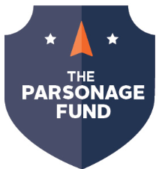
Final Reflection
Please complete this form by the deadline you were assigned when you received your Parsonage Fund award. If you do not submit a Final Reflection, you will be ineligible for Parsonage Fund support in the future. You’ll need to save this form to your computer before entering information.
Your answers will be shared with donors who support the Parsonage Fund – the donors love to hear about the types of projects and experiences students have as a result of their support, so we encourage you to take your time and give thoughtful, meaningful answers to the five prompts below. Please also feel free to share any photos from your experience by emailing them to parsonagefund@northland.edu, or if you have other materials you’d like to share, get in touch with the Parsonage Fund Coordinator.
Name: Click here to enter text.
Class Standing: Choose an item.
Academic Major: Click here to enter text.
Project Title: Click here to enter text.
- Brief description of your project (one paragraph or less):
Click here to enter text.
- Explain how this opportunity has enhanced your education at Northland:
Click here to enter text.
- Describe your favorite part of the project/activity:
Click here to enter text.
- Explain how this project will impact your future:
Click here to enter text.
- Give details of how you shared your Parsonage experience with the Northland community. Include details of where it happened, who was the audience, and when it occurred. If the activity changed from what you originally proposed, please explain why:
Click here to enter text.

