Appendix I: Examples of Successful Individual Proposal Application Materials
This appendix includes examples of an application, budget, and documentation taken from a variety of successful proposals.

- Application

Question 1
Jessica was a writing major and she submitted a proposal to go to a writing conference. The committee felt Jessica’s answer to question 1 was well written and succinct, yet still provided enough details for the committee to understand what the project entailed and why it was important to Jessica.

Question: Include a detailed description of the proposed project. This includes the purpose of the project, important timelines, organization goals/mission statements, etc. This should include information that provides the Review Committee with evidence of the project value.

Jessica’s Response: My project is to attend Iowa State University’s Symposium on Wildness, Wilderness, and the Creative Imagination held on the Iowa State campus February 25-27. The symposium is sponsored by Iowa State’s Creative Writing and Environment Master of Fine Arts program, to which I have applied for graduate school next fall. The event features readings by published nature writers and M.F.A. students and faculty, as well as panel discussions, documentaries, and book signings. I also attended last year’s symposium through Parsonage funds and was encouraged to return this year by the ISU faculty members I met. While last year as a prospective graduate student, I focused on getting a feel for the program/faculty, the campus, and the city in addition to attending the symposium events, this year as an applicant to the Creative Writing and Environment M.F.A. program, I will focus on solidifying the relationships that I made previously and networking with fellow students and writers. I think the reason that any writer attends events such as this one is to find a sense of community, support, and inspiration; writing can be a very isolating activity, but what draws me to this symposium is the same thing that drew me to ISU’s Creative Writing and Environment M.F.A.: the opportunity to interact with writers engaged with concerns of nature and the environment and to be professionally and personally nourished by their company and their work.

Question 2
Tyler was a Natural Resources major proposing to present his capstone research at a conference. The committee felt his response clearly articulated his goals for the experience and how this conference would help meet them.

Question: How will you benefit from completing this project? Include at least three examples that illustrate how you will benefit. These will be considered your personal goals for the project. Draw a direct connection between your academic major and/or additional interests and the proposed project.

If your proposal is to attend a conference, you can choose to discuss three
sessions you will attend at the conference and why those sessions are important
to you instead of discussing goals. Draw a direct connection between your academic major and/or additional interests and the proposed conference.

Tyler’s Response: Over the past year, I have worked to complete my Senior capstone project examining "The Effects of Native Herbivores of Eastern Hemlock Seedlings and Surrounding Plant Communities". Now that I have completed this work, it is my goal to share the information I have gained with the wider scientific community. The best place for me to do so is at NCUR. At this conference I will be able to share my research with an international community of students, professors, and researchers while also improving my communication skills. This conference will also be a great opportunity to meet professionals and dedicated students in a large array of scientific fields, therefore increasing my professional network. There is a graduate and professional school fair at the conference as well. This is a great place to look for graduate opportunities that will advance my career. My last goal for this project is to publicize Northland College and spread the name of our small school to many who have probably never heard of it before.

Question 3.
Adrienne submitted a proposal to attend a women’s leadership conference. Her response below received excellent remarks from the committee:

Question: What are your plans for sharing your experience with the Northland community? Examples might include a campus-wide presentation, classroom presentation, tabling, brown-bag discussions, panel discussions, poster display, Drifts article, etc. YOU MUST COMMIT TO A SPECIFIC PLAN – tell us what you will do, when you will do it and where you will do it.

Adrienne’s Response: I think that this experience will be an important one to share with my fellow students and other members of the Northland community. I have talked with the editors for Drifts about an article about the conference in the paper. My article will discuss the experience I had at the conference, as well as the particular issues that were addressed about women in the media, gender imparity in politics and other leadership positions, and what we can do to move forward and create greater gender equality in our community. I will submit my article to them by November 7th and it will run in the November issue of the paper. I am also encouraged that, at the conference, I will learn and develop other ways in which I can make this conversation an ongoing one at Northland and in the greater Ashland community. This conference will also undoubtedly give me much to contribute in the classroom and within the Sociology department, which I will be glad to share with my classmates.

Question 4:
Katherine applied to an environmental writer’s conference. Below is an example pulled from Katherine’s budget rationale that the committee found exemplary.

Question: Provide a written rationale for each aspect of your budget. YOU MUST provide evidence of the actual and projected costs with supporting documents. Please request only the funding that you absolutely need to complete your project.

Katherine’s Response:
- Conference Registration: A registration fee of $550 covers four days of the conference (Wed late afternoon through Sun mid-afternoon), including 4 morning writing workshops, a brief individual writing conference with Richard, and other activities to be announced. Registration fee covers only Wednesday dinner and Sunday lunch. (http://www.umt.edu/ewi/app_info.aspx)
- Travel in personal vehicle (140 miles): I will drive to and from the Duluth Airport, a 70 mile trip.
- Meal costs: I will have to provide all but two meals during the conference. I will use the kitchen at the hostel to prepare meals.
- Lodging costs: I am staying at Hutchins Hostel, which is a few blocks from the University of Montana and the least expensive lodging in Missoula, at $29 per night.
- Flights: I am flying because it is the fastest way to get to and from Missoula, so I will miss the least amount of class.
- Other travel costs: I will park my car at the Duluth airport for 6 days, at $9 per day. (http://www.duluthairport.com/airport-parking.php)

Question 5:
Louis did a service learning trip over May Term. He received credit for this as a Field Experience. His plan for reflection showed that he was serious about following through with this commitment.

Question: Please detail how you will reflect on your experiences during the project/conference. Reflection must include written or verbal thoughts and feelings about your experiences. Explain which methods of documenting your experience (journal, photos, discussions with other participants, etc.) you will use. Caution: if you plan to use photographs as documentation, you will need permission to use photos of people, displays, exhibits, etc.

Louis’s Response: I am committed to writing 2-6 page journal entries every single day of my trip. I will also be keeping a photography journal via Facebook throughout the duration of my journey. In case I lose my journal, I will also be writing my entries in an online format so that they can be preserved. I hope to accumulate as many personal stories as possible of the people I meet, so I will also be carrying out in-depth discussions with these people.

- Budget
The Excel budget sheet that has been provided for you has three pages for you to fill out shown below (Supplies, Fees, Membership, Travel, and Budget Summary). When you open the document, you will see along the bottom the following:

By clicking on the name, the worksheet will come into view. All three pages must be completed. If you are not requesting anything on one of the pages, adding a zero (if there isn’t one already) is helpful.

Within the budget, there are a variety of formulas already imbedded. For example, when calculating the costs for meals, you will see the following table:

By adding a number in the ‘# of meals’ column, the table will automatically total the cost. In other sections, such as the flights and misc. expenses, you will need to add up totals. Use these totals in your final budget summary worksheet, which looks like this:

Attempt to capture the total project cost, and then list ALL sources of other funding. For example, if you are volunteering at a conference to reduce the cost of attendance, you would add the total cost of registration to the total, and then add a line subtracting this amount under the other funding section. This allows the committee to see your full contribution to the experience.

- Examples of Budget Justification

The best way to submit documentation is by creating one PDF or WORD document which contains all budgeted items. It is also acceptable to scan brochures and save them as separate documents. Web links are not acceptable and anything that is unreadable is also not acceptable.

Below is an example pulled directly from Brittany’s application for attendance and travel to a conference. The documentation shows the costs. In addition, the applicant added a short description below each item so that the committee knows what they are looking at.
(Note: Images have been shrunk to fit on page. When submitted, they were large enough to read all details)

Verification of the cost of the flight $399.80
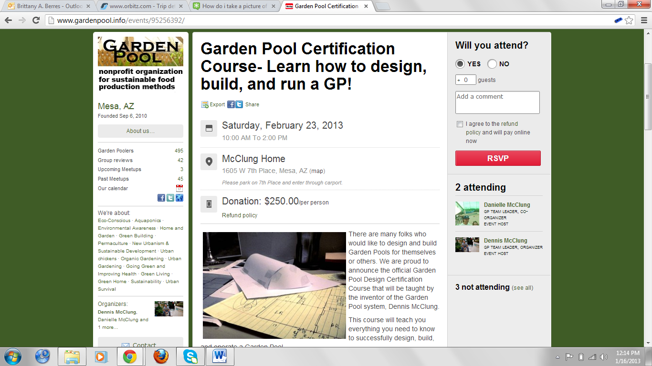
Verification of the cost of the Garden Pool Certification Course $250.00

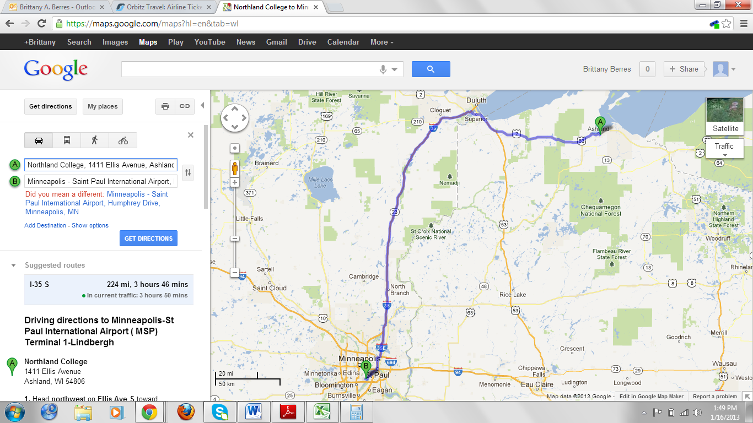
Verification of the distance between Northland College and the airport I will be able to fly out of. Round trip will be 488 miles. The cost of this at $0.25 per mile calculates out to $122.00

